The images from both cameras are read as 3-channel color images at pre-processing, where they are converted into the HSV color space. Colors within a pre-defined range are removed, i.e. bright red and green (Fig. 1), based on the assumption that we cannot drive on grass, and that obstacles/warnings on the road are often bright red.

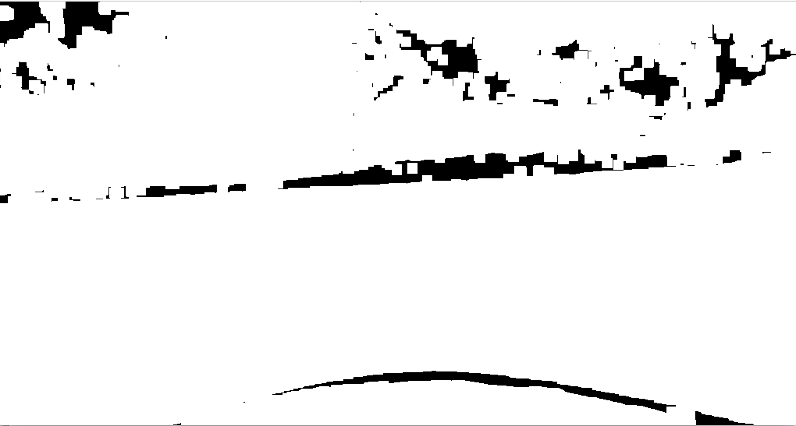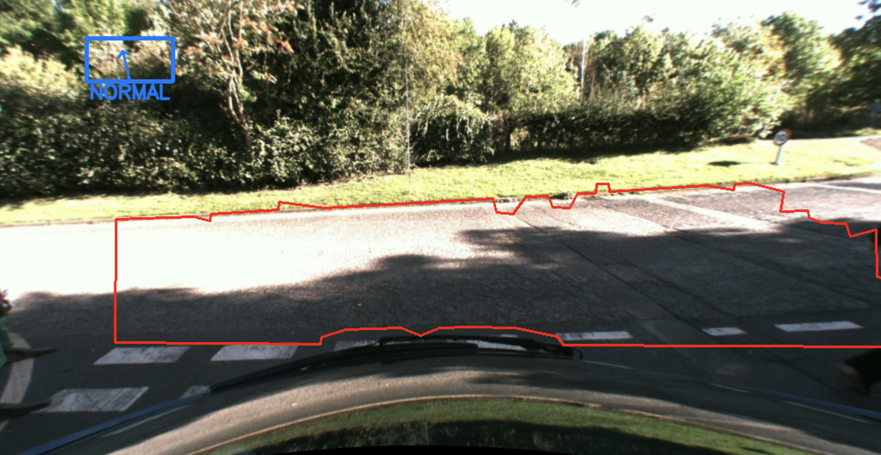

Figure 1 A mask is generated for the green, grassy region, allowing for clean removal from the detected plane.

The effects of illumination changes are then minimized as much as possible on both images by converting the images into the YUV color space and performing histogram equalization on the luminance channel. The Gaussian blur of the luminance channel is also subtracted from the original to remove low frequency information, which includes illumination. Histogram matching is then used on the resulting images to make them more similar to one another, accounting for the differences caused by the use of different cameras. Thresholding removes any remaining bright colors, e.g. glare from reflection.

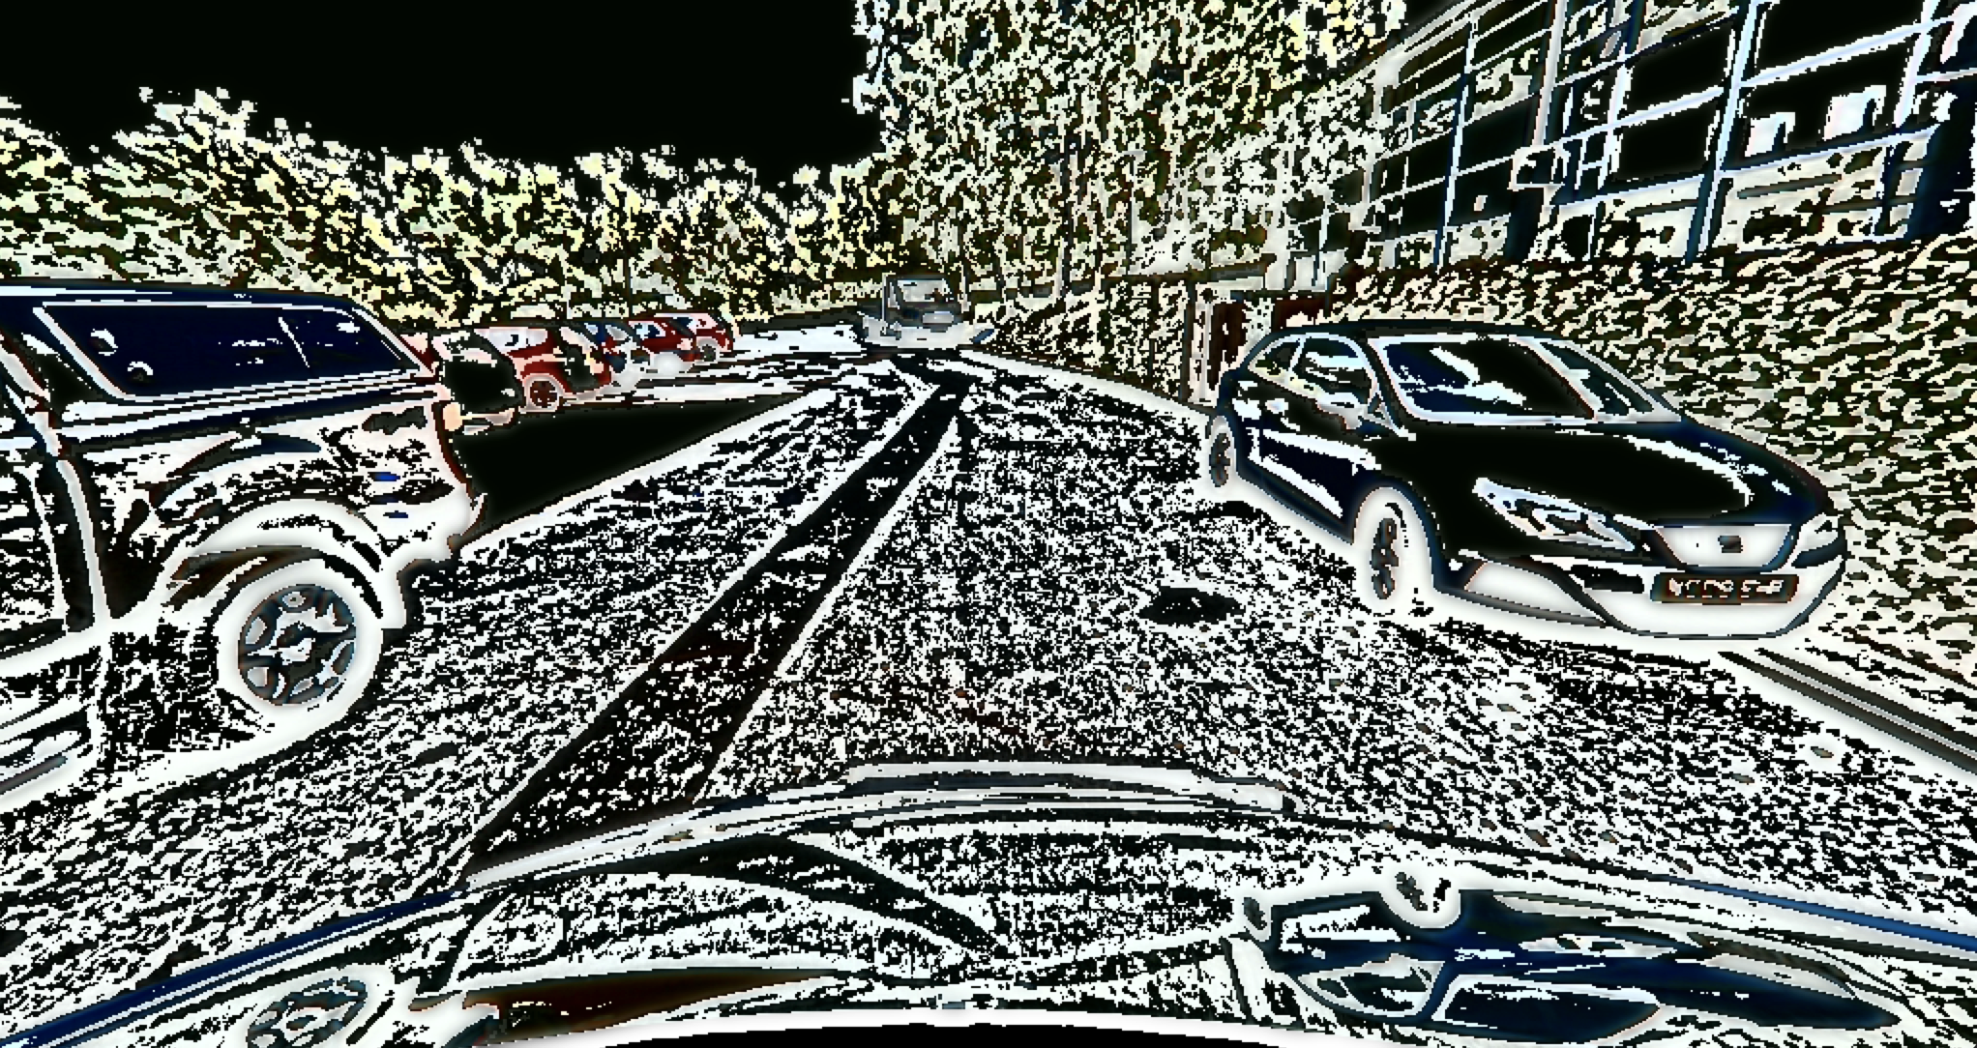

Figure 2 Following histogram equalization and the subtraction of the Gaussian blur on the luminance channel, much of the luminance has been removed. This increases the resiliency of the algorithm to varying lighting conditions.

A predefined mask is applied to the pre-processed images to reduce the sample space in which we look for a plane (Fig. 3), allowing the calculation of the 3D depth points, and RANSAC, to be run more efficiently. We repeatedly try to fit a plane to three randomly chosen 3D points, and any remaining points with a distance to the plane that exceeds a certain threshold is discarded. After 50 iterations, we take the plane with the greatest number of these ‘inliers’, and project its points back to 2D.

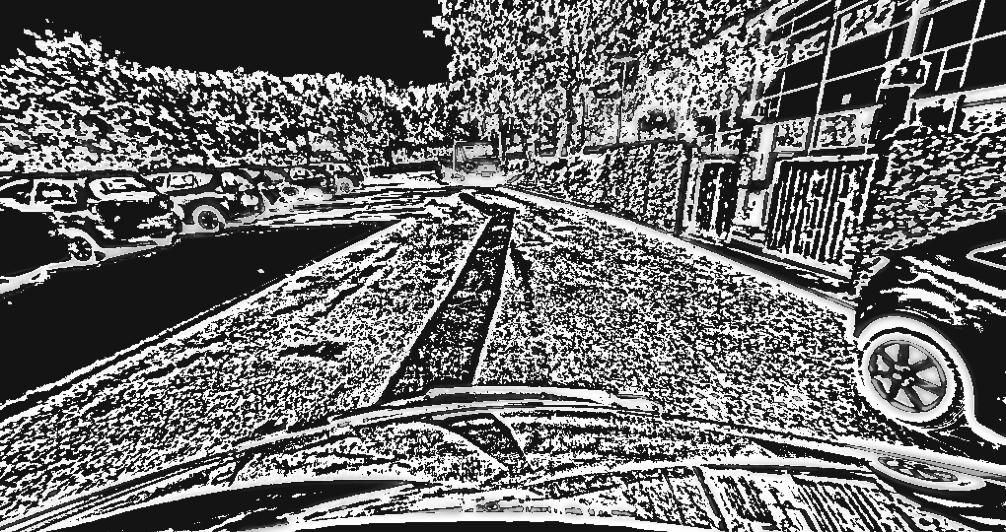

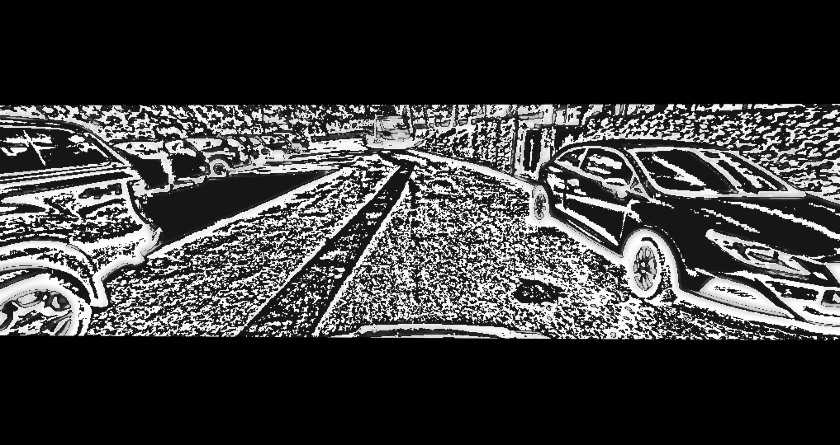

Figure 3 Applying a mask reduces the sample space, as we discount any points lying beyond the horizon, or before the front of the car.

The ORB keypoint detector is then used to identify objects within the color image. If there are enough keypoints clustered together, we can safely identify that it is an object; a bounding box can then be drawn around the object and filled, creating a mask for object removal from the plane.

These same clusters can also be used to identify any obstacles in the front of the car. Once we have the inlier points of our plane that were transformed from 3D, we draw a contour around them, creating a plane. Multiple iterations of erosion and dilation were carried out to remove noise. A trapezoidal region of interest is then fit and centered around the midpoint of the plane such that obstacles can be detected as they appear in front of the car. While the height of the trapezoid is extracted directly from the plane contour, the width is calculated based on a 16:9 ratio.

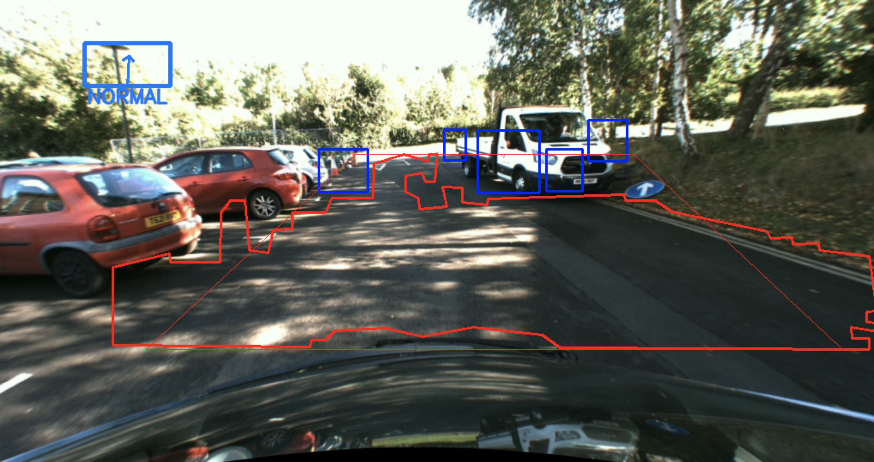

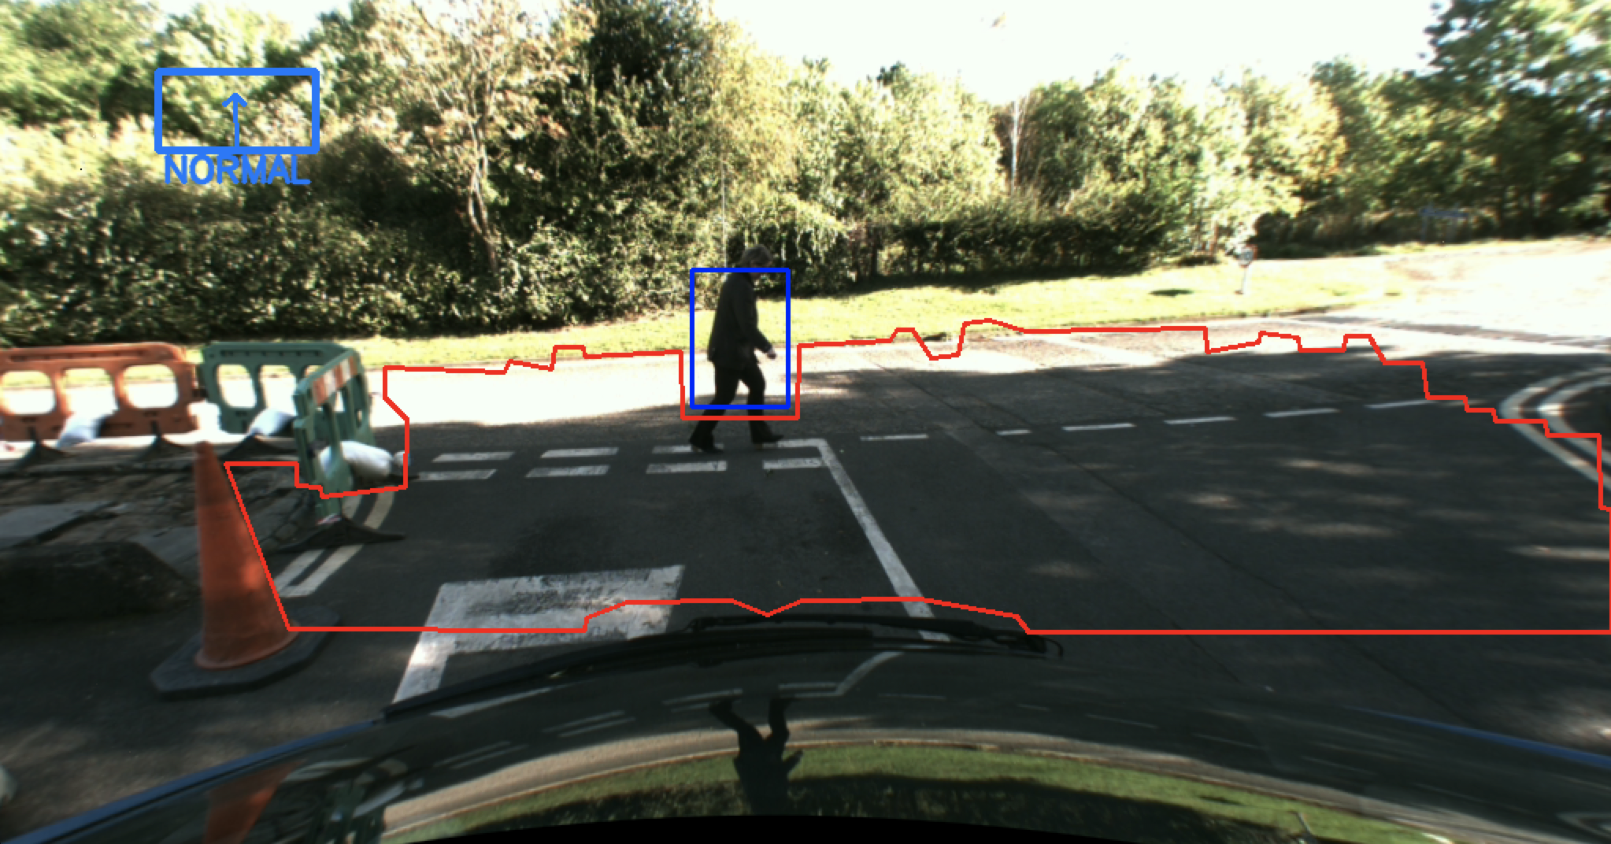

Figure 4 [L] Clusters of keypoints that overlap with the trapezoid (scales according to the plane) are deemed to be obstacles.  
 [R] Example of a detected obstacle, without the trapezoidal plot.

*Data analysis*

Based on observation, the plane detection appears to fail very often where an object/obstacle has a similar color to the ground. Shadows in the image also greatly affect results, and these effects cannot always be mitigated. Thus, we apply the Canny filter to a blur of the image (blurring reduces noise), with a mask around the central area, to detect any edges along the sides, which may have had its depth values distorted by shadows or color similarities.